**Course Syllabus – BAS 475 Time Series (Fall 2021)**

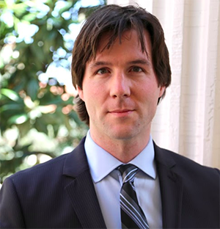

**Faculty Contact Information**

**Instructor**: Brian Stevens

**e-mail address**: [bstevens@utk.edu](mailto:bstevens@utk.edu)

**Office Hours**: [Click Here](https://www.youtube.com/playlist?list=PL-blpDu7mdw2BzRDd8hIynJ7_jGxYmVnh)

**Meeting Time and Place:** [Tuesday and Thursday at 4:30](https://www.youtube.com/playlist?list=PL-blpDu7mdw1Efv9O1-FPsgOy74xhf5TV)

**YouTube Channel –**[Click Here](https://www.youtube.com/channel/UCRjC9-Dmlz9lIlFy9F0ujXg/videos)

*The class will be the most recent stream with “Live” underneath it on YouTube.*

*The picture below does not show a stream in progress but if one is in progress, it’ll be the first video.*

**Class Videos Posted to Class Playlist (Unlisted on YouTube)**

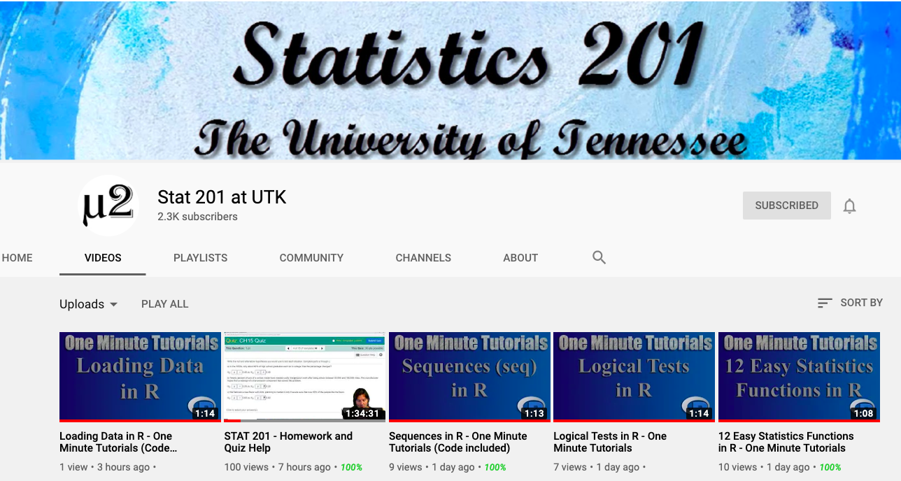

**YouTube Chat Guidelines:**

1 – The chat is public. Many students choose to use their actual name. You don’t have to use your actual name. You can create any YouTube you like but send me an email informing me of this name so I can make you a mod.

2 – Have fun! Yes, seriously. Relax and ask questions to both me and your classmates. We usually start class with just talking for 5-10 minutes about what’s going on in the class before lecture.

3 – Encourage each other. Feel free to cheer each other on in the chat.

**Course Description and Information**

**Textbooks:** The following textbooks will be used in our class. The first one is our course textbook which has the problems the homework will cover. The slides are also constructed from the textbook.

Resources: [Forecasting Principles and Practices 3rd edition](https://otexts.com/fpp3/) (Class Textbook)

[*Time Series Analysis with R*](http://r-statistics.co/Time-Series-Analysis-With-R.html) (Additional Help)

[Using R for Time Series Analysis](https://a-little-book-of-r-for-time-series.readthedocs.io/en/latest/src/timeseries.html) (Additional Help)

DataCamp: Link sent via announcement

**Software:** Nearly all work in this course will be done using RStudio and R version 4.1.1. Please update BOTH (separately) to the most recent versions at https://cloud.r-project.org/ and [https://www.rstudio.com/products/RStudio/ - Desktop](https://www.rstudio.com/products/RStudio/#Desktop). Some data processing may take place in Excel.

**Purpose of Course:** To teach business analytics students the basics of time series, cleaning data, presenting data, communicating results and decision making.

**Catalog Description:** Model building techniques for linear time series models, practical methods for univariate time series forecasting, Box-Jenkins forecasting methods, forecasting based on exponential smoothing, autoregression and stepwise autoregression, and forecasting from regression models. Use of standard computing packages. Major writing requirement.

**Course Overview:** Time series specifically covers data that has a time element to it. Any time we collect this type of data there are special considerations we must take when analyzing the variation within the data. Beyond understanding the variation, we must also know how to communicate that variation in the data to others. This course seeks to unify the knowledge of time series with data visualization skills in R.

Learning to program in R while simultaneously learning essential data mining concepts is difficult.

However, it is imperative that you pick this skill up if you plan on continuing in the business analytics program since BAS 479 assumes general fluency in writing your own code.

Why code? There are other tools out there that do allow you to point and click, e.g., SAS Enterprise Miner, SPSS, JMP, and to some extent Tableau. However, it takes time to implement those point-and-click screens or to implement new algorithms in a new programming language (e.g., at least 3 years in SAS). Being able to access the latest developments in the field will set you apart when you are looking for a job.

Here are some links as to why these skills matter to you:

* <http://blog.revolutionanalytics.com/2014/02/r-salary-surveys.html>
* <https://www.r-users.com>
* <http://money.cnn.com/2016/08/04/technology/general-electric-coding-jeff-immelt/index.html>
* <https://www.forbes.com/sites/laurencebradford/2016/06/20/why-every-millennial-should-learn-some-code/>

**How to Be Successful in This Course:**

1 – Attend class live

2 – Participate in discussion

3 – Start assignments early

4 – Ask questions (Via email or Discord) if you’re stuck for more than 5 minutes

Student’s Responsibility

* Be prepared for all classes
* Be respectful of others
* Actively contribute to the learning activities in class
* Abide by the UT Honor Code

Instructor’s Responsibility

* Be prepared for all classes
* Evaluate all fairly and equally
* Be respectful of all students
* Create and facilitate meaningful learning activities
* Behave according to University codes of conduct

**Course Objectives:** Students will learn

* to program/code in R,
* to process and manipulate data,
* to identify which time series technique is appropriate for the business problem at hand,
* to understand how to create visualizations that communicate results.
* to create a dashboard that allows users to interact with their data.

Content objectives include

* Programming Skills
  + dplyr (data manipulation)
  + forcats (For categorical variables! What did you think it was for?)
  + caret (Classification and Regression Training)
  + stringr (Handling strings)
  + tibble (Handling tables in an advanced way)
  + forecast (Forecasting in time series)
  + smooth (More time series functions)
  + lubridate (Handling time data)
  + ggplot2 (Amazing graphics)
  + plotly (Interactive graphics)
  + shiny (Interactive platforms
* Objective of time series analysis and examples of time series data sets
  + Time series models
  + Stationarity, autocovariance, autocorrelation
  + MA, AR, and linear processes
  + Sample ACF and its properties, its connections to forecasting
  + Causality, invertibility, and AR(p) models
  + ARMA(p; q) models and their properties
  + Linear prediction, partial ACF
  + Forecasting stationary time series
  + Parameter estimation: Yule-Walker estimation, MLE
  + Seasonal ARMA models
  + Classical decomposition of time series data, estimation of the trend and seasonality
  + Long memory time series
  + Exponential Smoothing

**Grading**

Grades are based on a combination of homework, exams, and lab work. To pass the class, your goal is to get at least a 95% average on labs, 85% average on homework, and 50% average on exams.

You will need to take extra care when submitting programing problems. A big issue is that when if your answer does not match up with the solution, it is often difficult to determine “how close” you were by “reading” the R code directly. Thus, we will almost always be unable to give “partial credit” for pure coding questions. Your grade on work that involves R code is completely dependent on whether the code produces the expected output (and “looks right”). On these programming problems, it is extremely important to follow directions with extraordinary precision to avoid losing points due to “providing a correct answer but to a different question”.

There are multiple graders for the course. Although each grader works from the same detailed grading rubric, invariably there will be discrepancies in how graders assign credit. This can result in student’s with essentially the same answers to receive different scores, and can result in course grades being on different scales at the end of the semester. To compensate for this, a rigorous statistical analysis of grader habits is performed at the end of the course, and adjustments will be made so that all students end up on the same scale (points are adjusted upwards to the “easiest” grader’s scale, if one exists).

**Homework (30% total)** – There are multiple homework assignments (**due by 11:59pm – Late assignments not accepted**) consisting of R programming and time series concepts.

You are free to discuss and work on assignments with others to better understand the concepts, but you must write up your own solution. Do not share electronic copies of work.

* It is ok if a study group may work through a programming assignment a develop a common set of computer code, ***provided* *everyone involved meaningfully contributed to the writing of the code.***
* Any written interpretation of the output and other answers to the problem must be in your own words; a study group is not allowed to come up with a “common written response” and have each member use it.
* Never acceptable: a study group generating a single document with each member changing the name of the author and submitting.
* Submissions from two or more students that appear to be near-copies will receive a grade of 0.

**Email submissions are not accepted. Late homework are not accepted.**

**Excessive output policy:** if you submit an assignment that contains “excessive output” (roughly defined as a page or more of unrequested output, like the contents of a dataframe) that is not explicitly requested, the grader will stop grading and no further points on the assignment will be awarded. Before submitting your assignment, open it up one last time to make sure everything looks good.

Any modifications to homework grading (e.g., incorrectly graded problems) must be completed within two weeks of the day that homework scores and comments on your assignment are posted. It is your responsibility to check the graded work with the solutions to ensure accuracy.

**Weekly Quizzes (20% total)** – Weekly quizzes will be posted to Canvas going over concepts. The goal of the weekly quizzes is to review the code and material covered. Weekly quizzes are assigned during the week and have unlimited attempts. They range between 4-8 questions. One weekly quiz will be dropped when computing the final average.

**Team Projects (20% total)** – Each group will consist of 3-4 students working together and helping each other learn code. Other groups will be graded on the following scale:

**10 Points – Initial plan uploaded on time**

**10 Points – Prototype upload on time**

**80 Points – Based on rubric for the project**

Given some students are better at coding than others, the goal is for students to learn from each other. This is your opportunity to share code within your group. Each group should have a unique assignment.

**Personal Projects (20% total)** – Just like the group projects, you’ll work on your own personal projects to turn in for the midterm and final. These projects are meant to help you create a portfolio of work to show to employers in the future.

**Personal Project One: Middle of Semester (TBA)**

**Personal Project Two: Last day of class**

**Proctorio Exam (10% total)** – Proctorioexams cover material from class and the assignments. The best way to study for these is to go over assignments and notes from class. Questions will either directly come from these or be based on the theory we are learning from the notes.

**Proctorio Final: Based on UTK Final Schedule**

**Course Grade** - Exams are typically curved (an exam may have 110 points but be graded out of 90), *but* *there is no curve for the course grade*. Course grades are assigned as follows:

|  |  |  |  |  |
| --- | --- | --- | --- | --- |
| A | 92+ |  | C+ | 78-80 |
| A- | 90-92 |  | C | 70-78 |
| B+ | 88-90 |  | D+ | 68-70 |
| B | 83-88 |  | D | 64-68 |
| B- | 80-83 |  | F | 64- |

The typical “A” student will achieve about 100% lab, 95% homework, and 83% exam averages. A typical “B” student will achieve 95% lab, 85% homework, and 75% exams averages. To pass the class (i.e., earn a C), your goal is to get at least a 95% average on labs, 85% average on homework, and 50% average on exams.

**Due to the open nature of projects, sharing work between groups or individuals can easily result in plagiarism. Do not share code outside your own group. If you are stuck, please ask Brian immediately. Do not send or receive work even after the course has ended. Most student conduct cases are from sharing work.**

**YouTube Screenname:**

Students can use an appropriate screenname other than their own name. If you wish to use a different screenname, please email me at [BStevens@utk.edu](mailto:BStevens@utk.edu) with the screenname you are using so I can add you as a moderator.

**Stream Labs Extra Credit:**

**Discord Extra Credit:**

Discord is a communication app that allows students to easily message students, TAs and instructors. All students are encouraged to join the Discord and interact. The more you interact on the Discord, the more points you get. Students can get up to 0.5 points for achieving level 5 on the Discord.

**Extra Credit and Final Grades:**

Both extra credit opportunities add up to a maximum of 1.7 total points on the final course grade. Grades are not rounded up after bonus is included on the final grade.

**Academic integrity:**

Collaboration will be necessary to master the material in this course, but the extent of collaboration that is allowed on different assignments varies:

* Analytics lab: working with classmates to develop a common set of answers is allowed, encouraged, and quite advantageous. However, make sure you’ve substantially contributed to all answers you submit.
* Homework (R code): developing common chunks of R code with classmates is allowed (so that numerical values output by the code match), but make sure you’ve substantially contributed to all answers you submit. If you submit work without understanding it, you’ll be overwhelmed by the in-class programming exams.
* Homework (written responses): you must respond to any questions asking for a written response in your own words; it is not ok to copy/paste others’ interpretations.
* Exams: no collaboration of any kind (written, digital, internet, oral, etc.) is allowed, and rigorous checks are in place to detect it.

For homeworks, convincing evidence of cheating will result in a non-droppable score of 0 for the assignment. For exams, convincing evidence of cheating will result in a score of 0 for the exam (and this exam will be the one of the pair that will count the most when appropriate) and, at the discretion of the instructor, an F in the course.

By submitting any assignment, you have pledged to agree to the Honor Statement:

*An essential feature of The University of Tennessee is a commitment to maintaining an atmosphere of intellectual integrity and academic honesty. As a student of the University, I pledge that I will neither knowingly give nor receive any inappropriate assistance in academic work, thus affirming my own personal commitment to honor and integrity.*

The Haslam College of Business holds **Integrity** as one of its four core values.  Integrity is essential to our community. Integrity is supported by openness, communication, accountability, professionalism, and the courage to live our values. Our core values provide the foundation for a collaborative community and for achieving our mission and vision. Therefore, the guidelines set forth inTheUniversity of Tennessee*Student Code of Conduct* will be followed in cases of academic dishonesty and misconduct.  **WE ADHERE TO THIS POLICY VERY STRICTLY.**If you are a registered student in this class, it will be assumed that you will abide by the following UT Honor Statement:  *"As a student of the University, I pledge that I will neither knowingly give nor receive any inappropriate assistance in academic work, thus affirming my own personal commitment to honor and integrity."*  For a complete text of the Code of Student Conduct, click the following link:

<https://hilltopics.utk.edu/student-code-of-conduct/>

**ALL HONOR CODE VIOLATIONS ARE REPORTED TO THE OFFICE OF STUDENT CONDUCT AND COMMUNITY STANDARDS.  VIOLATIONS WILL GO ON YOUR RECORDS IN ACCORDANCE WITH UNIVERSITY POLICY.**



The purpose of this **Campus Syllabus** is to provide you with important information that is common across courses at UT. Please observe the following policies and familiarize yourself with the university resources listed below. At UT, we are committed to providing you with a high-quality learning experience. I want to wish you the best for a successful and productive semester.

Provost John Zomchick

UNIVERSITY CIVILITY STATEMENT -- <http://civility.utk.edu/>

“Civility is genuine respect and regard for others: politeness, consideration, tact, good manners, gracious-ness, cordiality, affability, amiability and courteous-ness. Civility enhances academic freedom and integrity, and is a prerequisite to the free exchange of ideas and knowledge in the learning community. Our community consists of students, faculty, staff, alumni, and campus visitors. Community members affect each other’s well-being and have a shared interest in creating and sustaining an environment where all community members and their points of view are valued and respected. Affirming the value of each member of the university community, the campus asks that all its members adhere to the principles of civility and community adopted by the campus.”

EMERGENCY ALERT SYSTEM -- <http://safety.utk.edu/>

The University of Tennessee is committed to providing a safe environment to learn and work. When you are alerted to an emergency, please take appropriate action. Learn more about what to do in an emergency and sign up for [UT Alerts](http://safety.utk.edu/). Check the emergency posters near exits and elevators for building specific information. In the event of an emergency, the course schedule and assignments may be subject to change. If changes to graded activities are required, reasonable adjustments will be made, and you will be responsible for meeting revised deadlines.

ACADEMIC INTEGRITY

“An essential feature of the University of Tennessee, Knoxville is a commitment to maintaining an atmosphere of intellectual integrity and academic honesty. As a student of the university, I pledge that I will neither knowingly give nor receive any inappropriate assistance in academic work, thus affirming my own personal commitment to honor and integrity.”

YOUR ROLE IN IMPROVING TEACHING AND LEARNING THROUGH COURSE ASSESSMENT

At UT, it is our collective responsibility to improve the state of teaching and learning. During the semester you may be requested to assess aspects of this course either during class or at the completion of the class. You are encouraged to respond to these various forms of assessment as a means of continuing to improve the quality of the UT learning experience.

DISABILITIES THAT CONSTRAIN LEARNING

“Any student who feels he or she may need an accommodation based on the impact of a disability should contact the Student Disability Services (SDS) at 865-974-6087 in 100 Dunford Hall to document their eligibility for services. Student Disability Services will work with students and faculty to coordinate reasonable accommodations for students with documented disabilities.”

Accessible Information, Materials, & Technology -- <http://accessibility.utk.edu/>

WELLNESS -- <http://counselingcenter.utk.edu/> and <http://wellness.utk.edu/>  
The *Student Counseling Center* is the university’s primary facility for personal counseling, psychotherapy, and psychological outreach and consultation services. The *Center for Health Education and Wellness* is dedicated to a community model that is embodied in the **“VOLS HELP VOLS”** commitment: *We are all Volunteers. We look out for each other.* The Center manages 974-HELP, the distressed student protocol**,**case management**,**the Sexual Assault Response Team, and theThreat Assessment Task Force**.**